TITLE
IntelliCane : A Smart Embedded Cane with Safety features for the Elderly and Visually Impaired
AUTHORS
Mohammad Farish Iskandar Bin Mohd Syahidin, Ahmad Harith Imran Bin Mohd Yusof, Arifa Aqilah Binti Abdul Halim. Department of Mechatronics Engineering, International Islamic University Malaysia. Email: farish.a.iskandar@outlook.com, harithmy4@gmail.com, arifaaqilah.h@gmail.com
ABSTRACT
This paper details the development of the IntelliCane, a smart navigation aid designed to assist visually impaired and elderly users. The system operates on a dual-processor architecture where the NodeMCU ESP32 manages real-time sensor readings such as LiDAR, IMU, and GPS, while the Raspberry Pi 5 handles AI human detection using the HuskyLens. This project successfully integrates five core functionalities: power management, SOS fall detection, automated lighting, AI voice reporting, and obstacle avoidance. The development process validates the task partitioning and hardware interfacing required for mechatronics system integration. Experimental results show that the system effectively detects obstacles within a 30 to 80 cm range and transmits emergency GPS alerts via Telegram in less than 5 seconds, providing a reliable safety net for the user.
- INTRODUCTION
Elderly individuals and people with visual impairments face significant difficulties when moving independently, especially in unfamiliar, crowded, or low-light environments [1], [2]. Limited vision, slower reaction time, and reduced balance increase the risk of falling or colliding with obstacles [3]. Conventional white canes are passive devices that only detect obstacles after physical contact, providing late warnings and failing to detect raised or distant hazards [4], [5]. In addition, traditional canes do not include lighting or emergency SOS features, making it difficult for users to call for help in case of a fall or medical emergency [6]–[9].
Based on previous research, integrating sensors, feedback systems, and communication modules has been shown to improve safety and awareness for visually impaired and elderly users [10]–[12]. Therefore, this project aims to develop a Smart Cane, called IntelliCane, to enhance user safety and independence. The proposed system provides real-time obstacle detection with haptic feedback, automatic lighting in low-light conditions, and an emergency SOS feature with GPS tracking [13]. A dual-processor architecture using an ESP32 and Raspberry Pi 5 is implemented to ensure fast response for safety-critical tasks while supporting advanced system functions, overcoming the limitations of conventional canes.
Table 1: Table of Comparison
Ref/  Year | Title | Advantages | Disadvantages | Compared to my proposed system
Our Project | IntelliCane: Smart Safety and Mobility Aid for Elderly and Visually Impaired | Combines ToF obstacle detection, vibration feedback, automatic lighting, emergency SOS, GPS, and fall detection; dual-processor design for fast response | Prototype stage; no advanced medical monitoring | Balanced, practical, and designed for real-world daily use with strong safety focus
[9]  2015 | Ultrasonic Sensor-Based Smart Blind Stick | Low cost; simple obstacle detection using buzzer | Very short range (5–35 cm); no GPS, lighting, or emergency alert | My project offers longer detection range, SOS system, and better safety coverage
[10] 2013 | Smart walking stick for visually impaired people using ultrasonic sensors and Arduino | Affordable and simple design; detects obstacles up to 3 m | No emergency alert, no lighting, no fall detection | My project includes SOS, lighting, and fall detection for higher safety
[13]  2024 | Smart cane with obstacle detection and navigation assistance | Includes health sensing, GPS alert, obstacle and water detection | High cost; complex integration | My project is more affordable and focused on core safety needs

- METHODOLOGY
2.1 Project Development
Navigating unfamiliar environments independently is a significant challenge for visually impaired individuals. To address this, the IntelliCane utilizes five systems embedded in the product. Fig. 1 illustrates System 4, which uses the Bluetooth system and human detection button to figure out the visibility of humans in front of the cane. Meanwhile, Fig. 2 shows the integration of System 3, which has advanced object detection sensors to identify obstacles in the user's path, providing immediate vibratory feedback via servo to prevent accidents. Furthermore, this figure also details System 2, which integrates GPS tracking to lower the risk of getting lost and includes an emergency alert feature that allows the user to instantly send their location to caregivers by the press of a button or when the cane is stolen. Lastly, System 1 ensures safety by providing a light that will activate automatically when the surrounding is dark. Fig. 3 indicates the flow chart of all the systems that represent the work principle of IntelliCane.
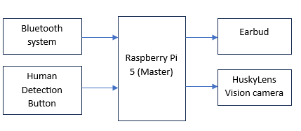
Fig. 1 Block diagram of System 4 (Human Detection System)
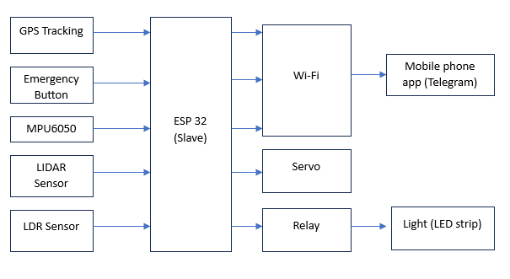
Fig. 2 Block diagram of System 1 Automated Lighting System), System 2 (Emergency Alert System), and System 3 (Object Detection System)
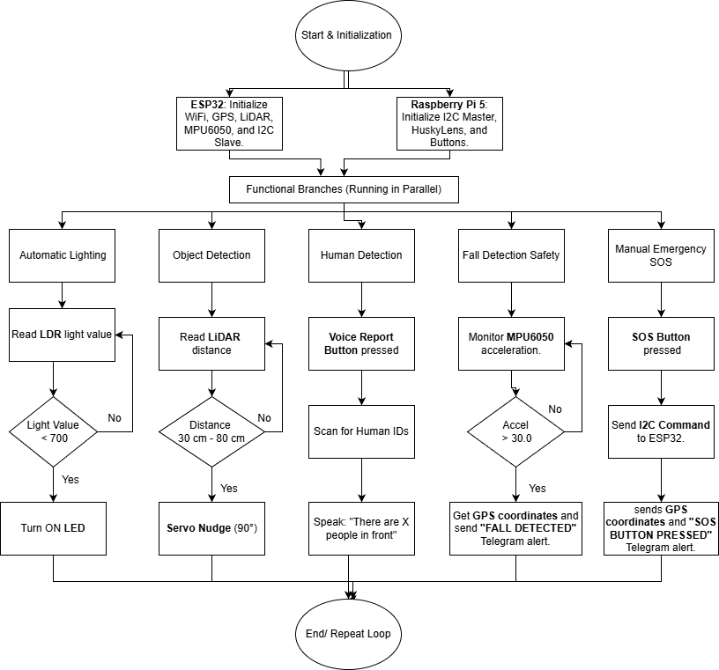
Fig. 3 Flowchart explaining the work principle of IntelliCane
2.2 Schematic Diagram and Prototype Setup
Fig. 4 is the prototype design of the IntelliCane which highlights the mechanical setup and component placement. It illustrates the mounting of the components, alongside the actual internal arrangement of the Raspberry Pi 5 and ESP32 within the custom enclosure. Additionally, Fig. 5 exhibits the complete circuit diagram of the system, detailing the wiring connections between the power management unit, the dual-processor architecture, and the peripheral sensors for System 1 (Automated Lighting), System 2 (Emergency Alert), System 3 (Object Detection), and System 4 (Human Detection).
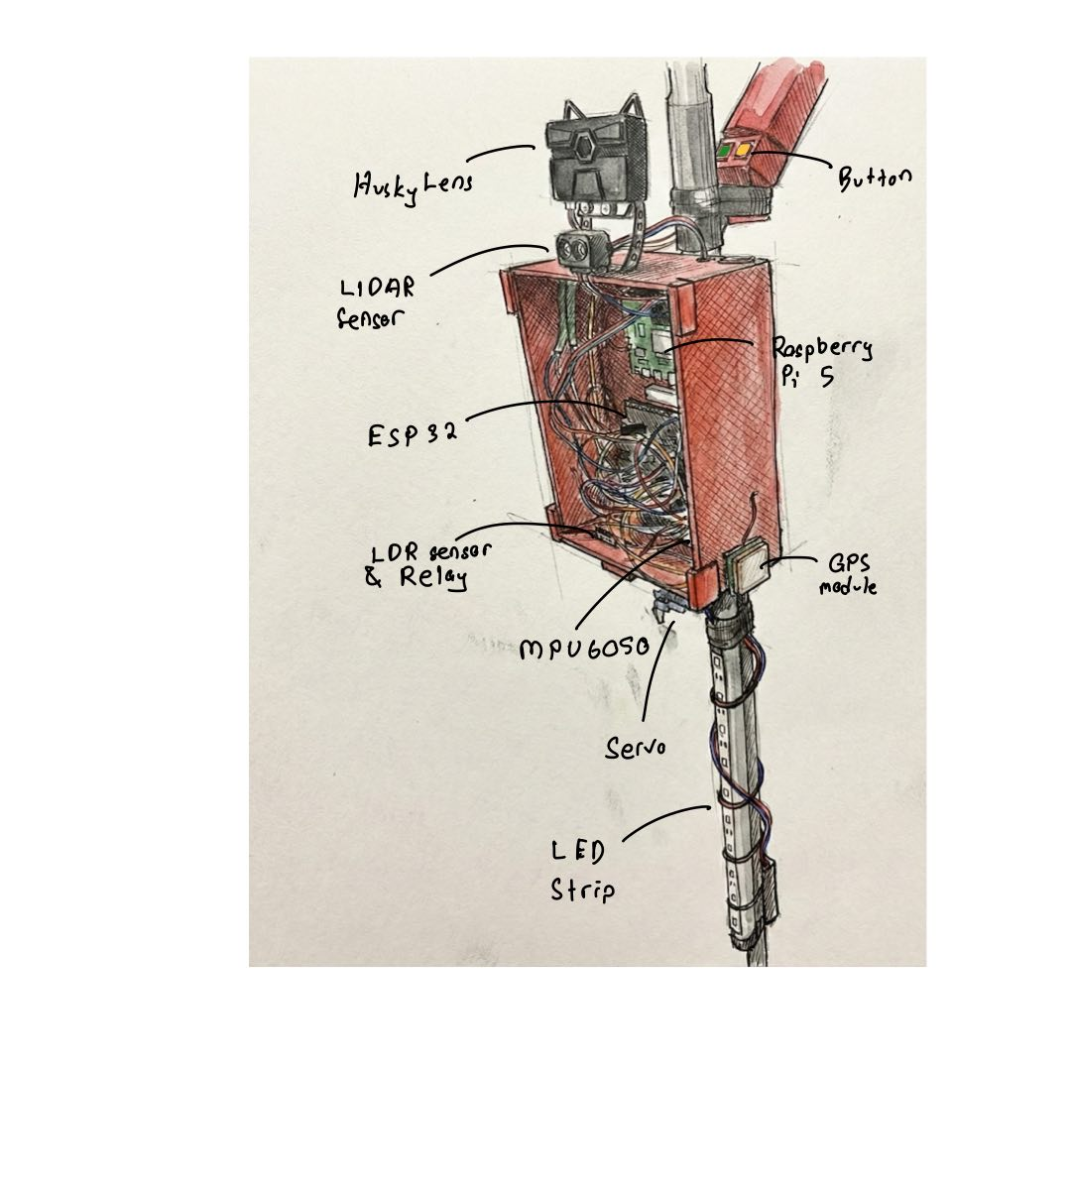
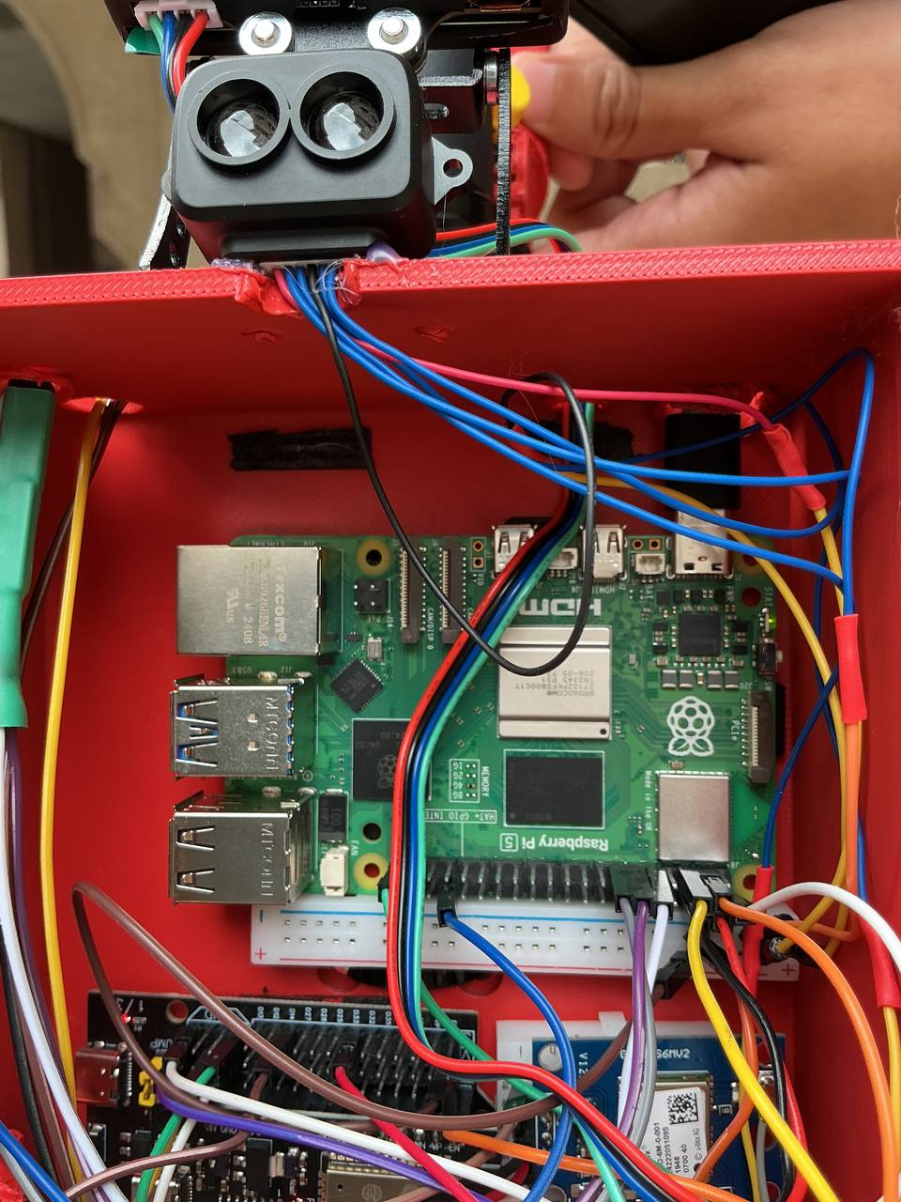

Fig. 4 Prototype Schematics and the actual setup

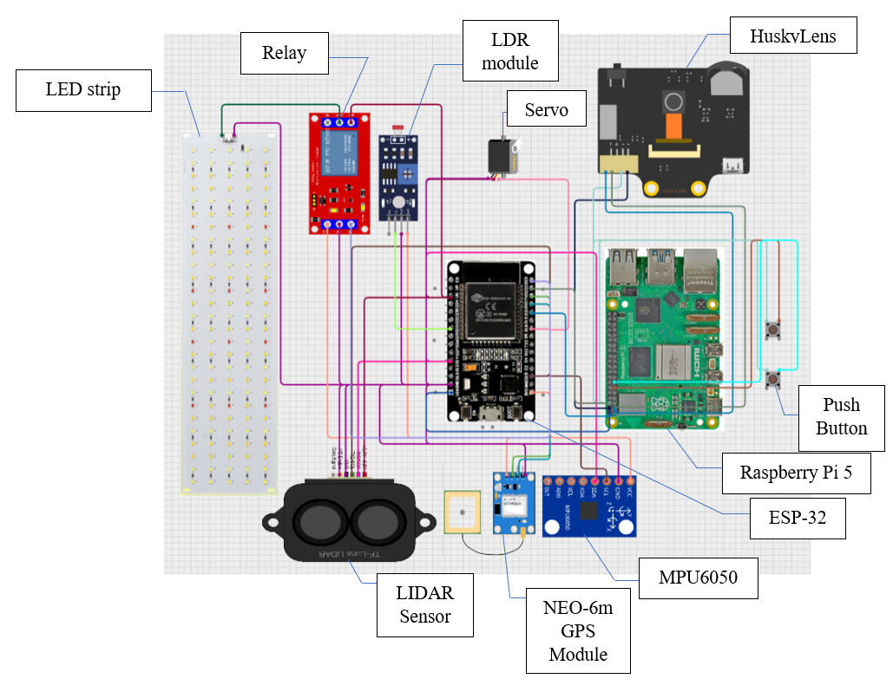
Fig. 5 Circuit Schematics on Cirkit Designer

3. RESULT AND DISCUSSION

3.1 System 1 (Automated Lighting System) Analysis
The lighting system, designated as System 1, was designed to solve the visibility issue for users walking in low-light environments. The hardware setup consists of an LDR sensor connected to the ESP32 and an LED strip controlled via a Relay Module. The main goal of this test was to verify that the relay triggers reliably at the correct light threshold without flickering.
In the firmware, we set a specific threshold value of 700 for the analog reading. The logic is simple: if the analog value drops below 700, the system assumes it is "dark" and pulls the relay signal LOW to close the circuit and turn on the LED strip. If the value is above 700, the relay stays HIGH (open), keeping the light off to save battery. We tested this by simulating day and night cycles. For the "bright" condition, the cane was placed under normal room lighting. For the "dark" condition, we covered the LDR sensor completely to block out ambient light. As seen in Fig. 6, the system responded immediately to the changes. The relay audibly clicked and the LEDs turned on as soon as the sensor was covered, confirming the threshold of 700 is effective for distinguishing between a lit room and darkness. Table 2 below summarizes the behavior we observed during the functional test.
Table 2: System 1 Response Test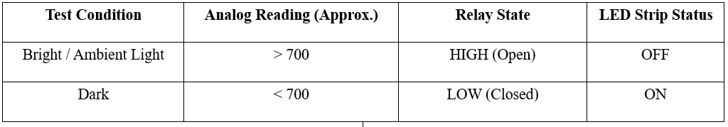
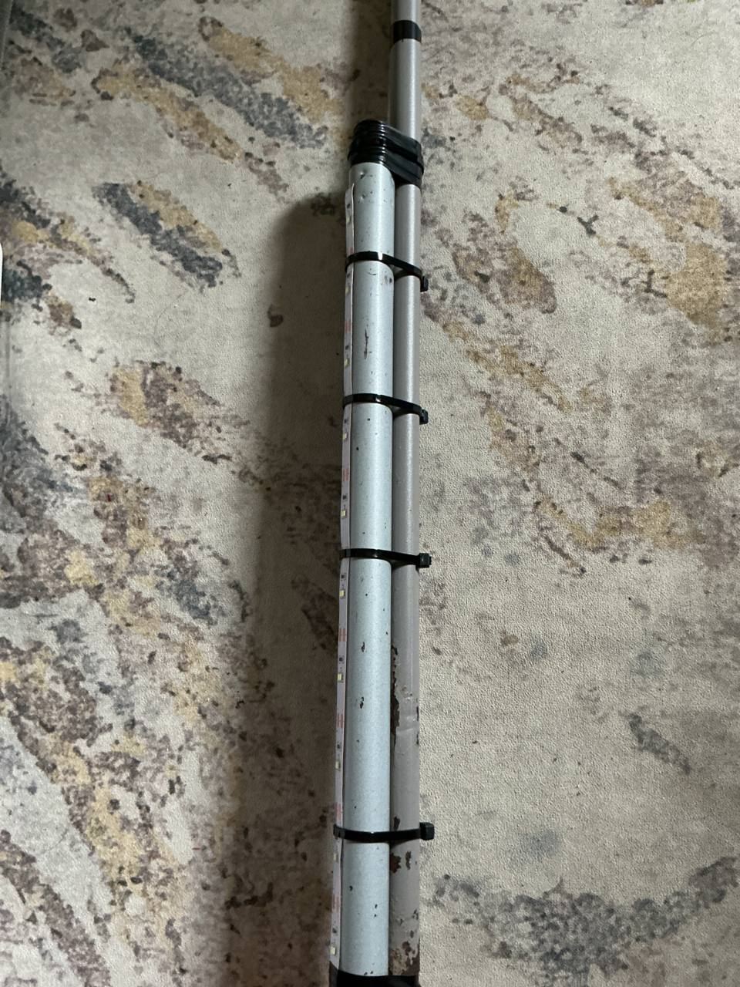
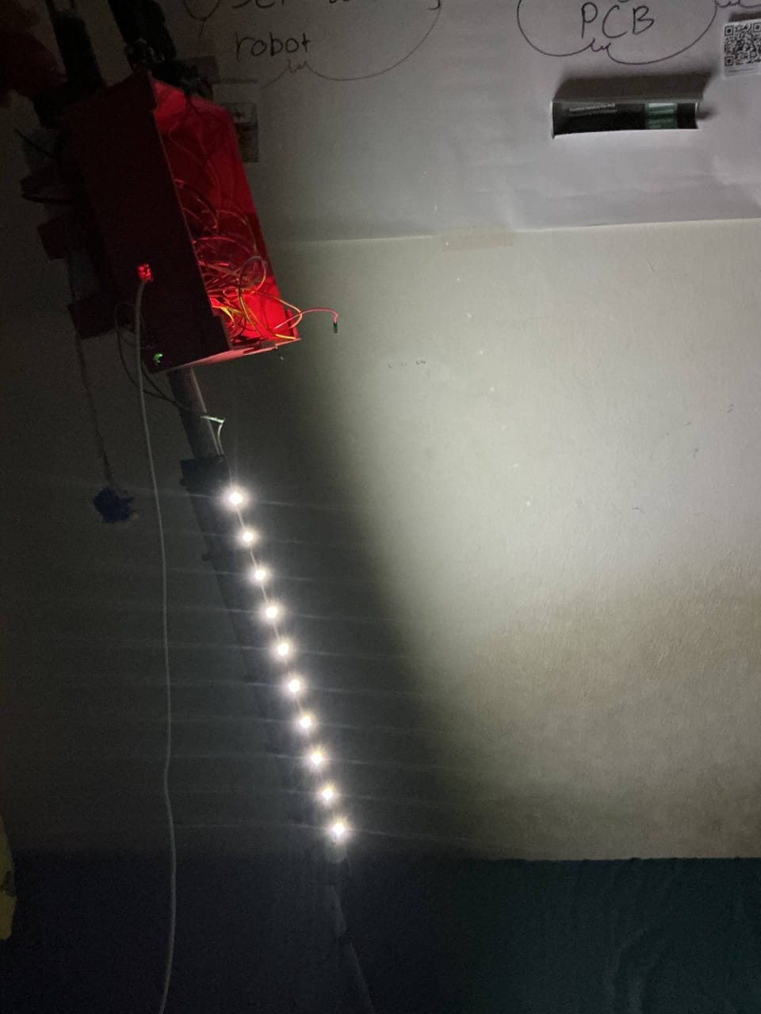

a) Bright

b) Dark

Fig. 6 Automatic light system for two condition, bright and dark

3.2 System 2 (Emergency Alert System) Analysis
The Emergency Alert System, designated as System 2, acts as the primary safety net for the user. It triggers under two conditions: the first is manual, where the user presses the SOS button during a panic situation; the second is automatic, where the cane detects a sudden fall. In both scenarios, the main goal is to send the user's precise GPS location to a guardian via Telegram. We implemented the logic on the ESP32 to handle the communication. The fall detection algorithm uses the MPU6050 accelerometer. In the firmware, we calculate the total acceleration vector using the square root formula. Through trial and error by dropping the cane on a mattress, we set a trigger threshold of 30.0 (approximately 3G). We also added a 5-second cooldown timer in the code to prevent the system from sending repeated alerts if the user picks the cane up immediately after a fall.
For the manual SOS, the button is connected to the Raspberry Pi. When pressed, the Pi sends an I2C command (Value: 1) to the ESP32. The ESP32 then fetches the latest coordinates from the NEO-6M GPS module. We observed that the GPS accuracy relies heavily on the number of satellites acquired. The system works significantly better in open spaces where the satellite signal is strong, achieving an accuracy of approximately 5 meters. In indoor environments, the location fix may take longer or be less precise.
Fig. 7 shows the actual alerts received on the guardian's phone during testing. The first message (12:15 PM) shows the response to the manual button press and identifies the reason as "SOS BUTTON PRESSED". The second message (12:16 PM) was triggered by a simulated fall and identifies the reason as "FALL DETECTED". In both cases, the system successfully generated a clickable Google Maps URL which directs the guardian to the exact location. We also measured the latency, which is the time between the event and the message arriving on the phone. As shown in Table 3, the manual button is slightly faster because it does not require the calculation and verification time needed for the fall detection algorithm
Table 3: Emergency System Response Latency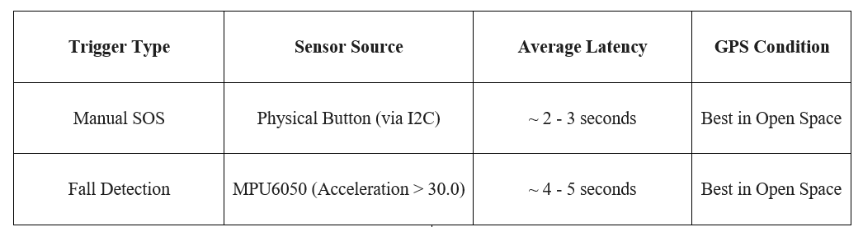
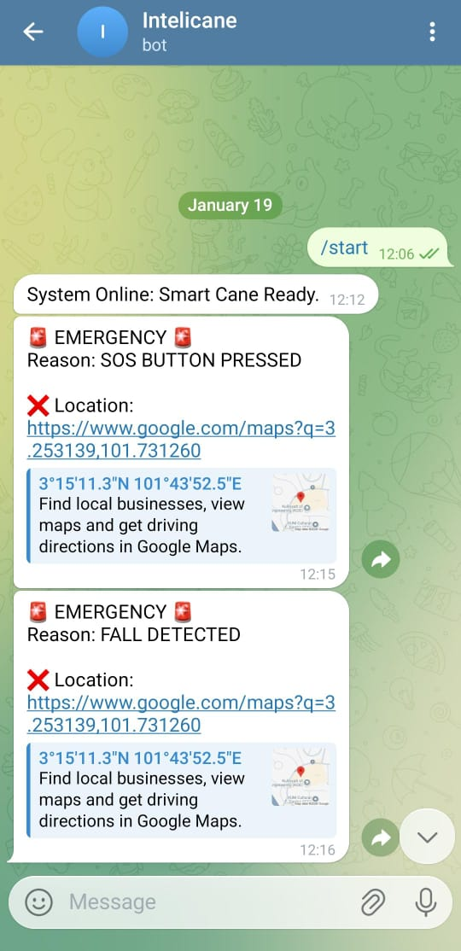
Fig. 7 Emergency message received by two condition via Telegram

3.3 System 3 (Object Detection System) Analysis
System 3 handles obstacle detection using a TF-Luna LiDAR sensor and a micro-servo motor. The goal of this system is to provide discreet haptic feedback to the user when an obstacle is within a critical range, without relying on audio alerts that might be drowned out in noisy environments.
The firmware logic polls the LiDAR sensor every 100 milliseconds. This sampling rate was chosen to ensure real-time responsiveness while preventing the servo from jittering due to sensor noise. We defined a specific "Safety Zone" in the code between 30 cm and 80 cm, as illustrated in Fig. 8. Any object detected closer than 30 cm is ignored to prevent false alarms caused by the user's own feet or the ground during the swing of the cane. Objects further than 80 cm are considered safe and do not trigger an alert.
When an object enters the 30-80 cm range, the system triggers the servo to rotate to 90 degrees and immediately return to 0 degrees. This rapid movement creates a physical "nudge" or kick on the cane's handle, alerting the user to stop or change direction.We tested the system against different obstacles including a wall, a chair, and a person's leg. As shown in Table 4, the LiDAR sensor provided consistent distance readings on solid surfaces. The servo response was instantaneous once the object entered the threshold.
Table 4: Object Detection and Haptic Response Test
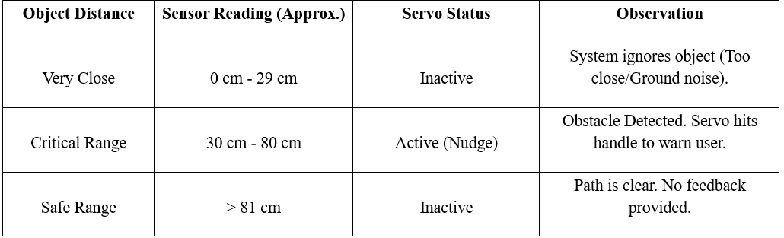

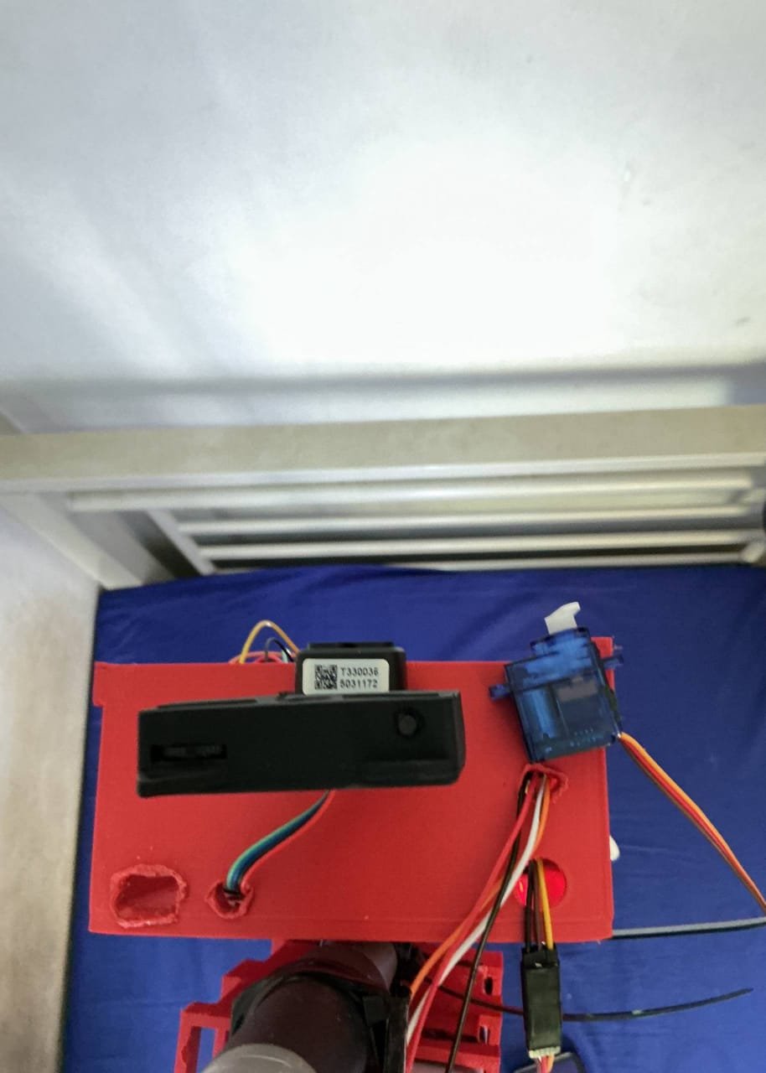
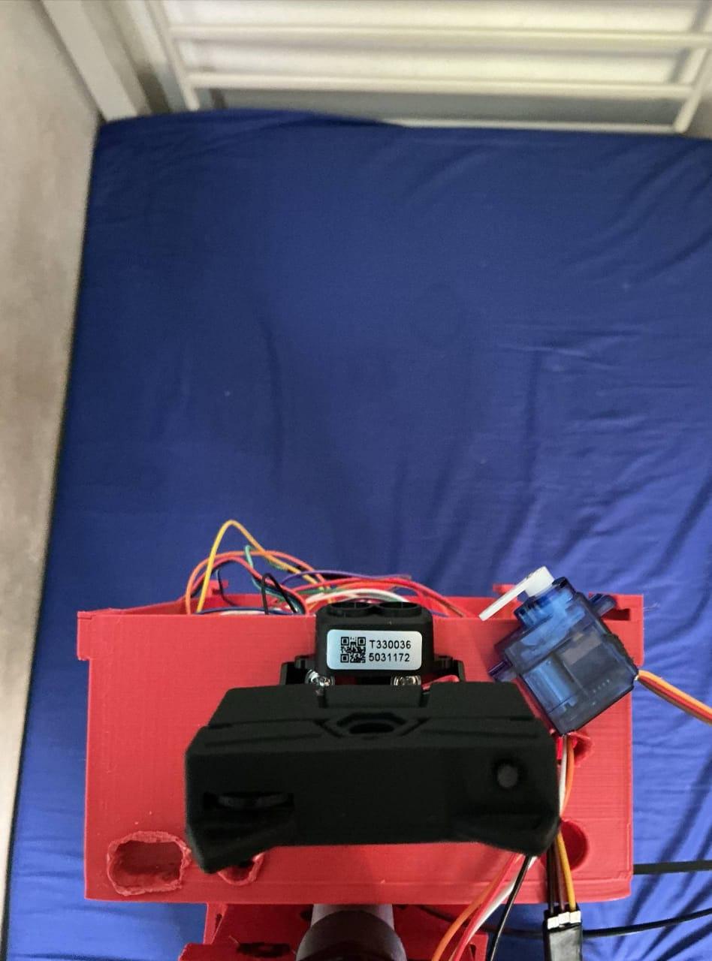

b) Safe Range
a) Critical Range
Fig. 8 Diagram of the detection zones.

3.4 System 4 (Human Detection System) Analysis
System 4 enhances user awareness by providing semantic feedback on human presence, distinguishing it from generic obstacle detection. The architecture interfaces a Raspberry Pi 5 with a HuskyLens AI camera via I2C, triggered by a physical push button. Upon activation, the Python firmware filters the camera data to count objects matching ID 1 ("Person"), as illustrated in Fig. 9. Once the count is complete, the Raspberry Pi 5 dynamically constructs a status message indicating the number of people detected or a clear path. We utilized the espeak-ng library to convert this text string directly into speech. This approach allows the system to work entirely offline without needing an internet connection for voice processing.
We tested the detection capability in an indoor hallway with varying numbers of people. Table 5 shows the results. The system accurately counted up to 3 people within a 2-meter range. We observed that the HuskyLens requires good lighting to accurately identify faces. In very dark conditions, the detection rate dropped, although the system still correctly reported "Path is clear" when no one was present.
Table 5: Human Detection and Audio Feedback Test
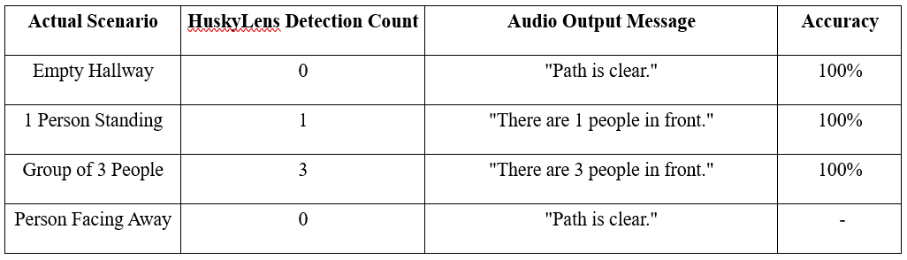
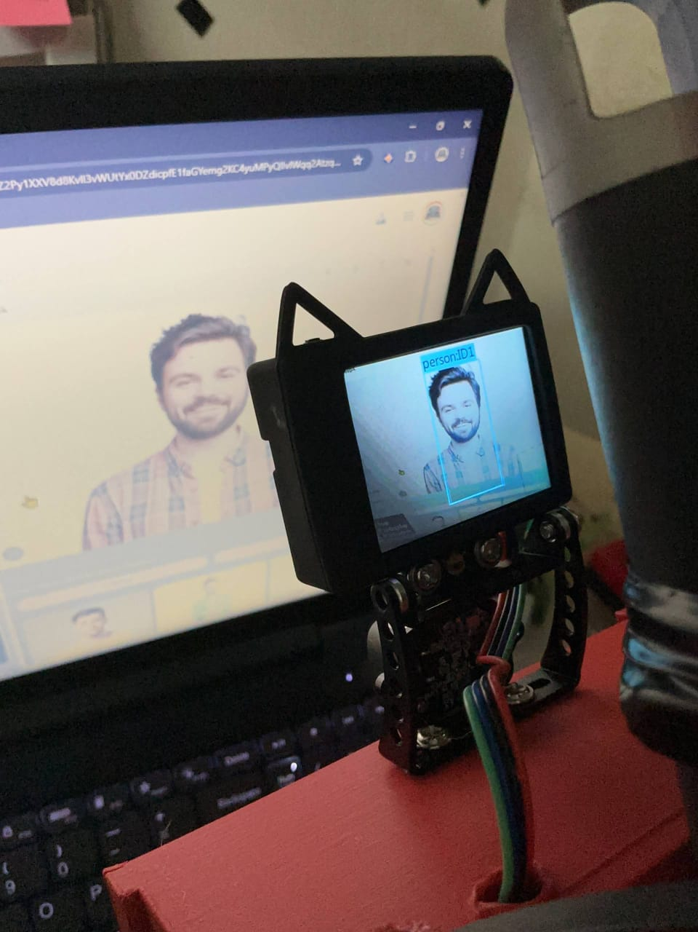
Fig. 9 View from the HuskyLens camera showing the bounding boxes around detected faces
3.5 System 5 (Power Management System) Analysis
Our initial power system was a custom-made module using three rechargeable 18650 batteries, a charging board, and a voltage booster, as shown in Fig. 10(a). During testing, we found that this setup was not strong enough to handle the high power needs of the Raspberry Pi 5, especially when the camera was processing object recognition tasks. The batteries could not supply sufficient current quickly enough, which caused the system to display a low-power warning and shut down unexpectedly after only 15 to 20 minutes of operation.
To ensure the Smart Cane is reliable and safe for the user, the custom battery pack was replaced with the high-capacity 20,000 mAh commercial power bank shown in Fig. 10(b). This new unit provides a stable 3A output, which meets the power requirements of the electronics during complex tasks. Table 6 compares the performance of our initial custom design versus the final commercial solution. As a result of this upgrade, the device can operate for a significantly longer duration on a single charge, making it a practical and dependable tool for daily use without the risk of sudden shutdown.
Table 6: Power System Performance Comparison
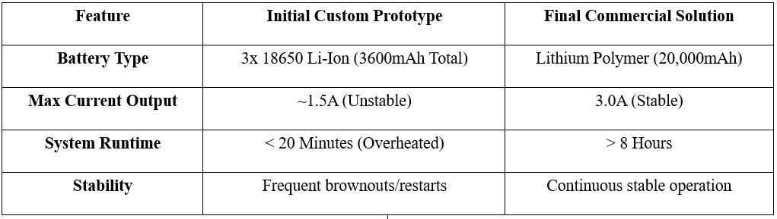
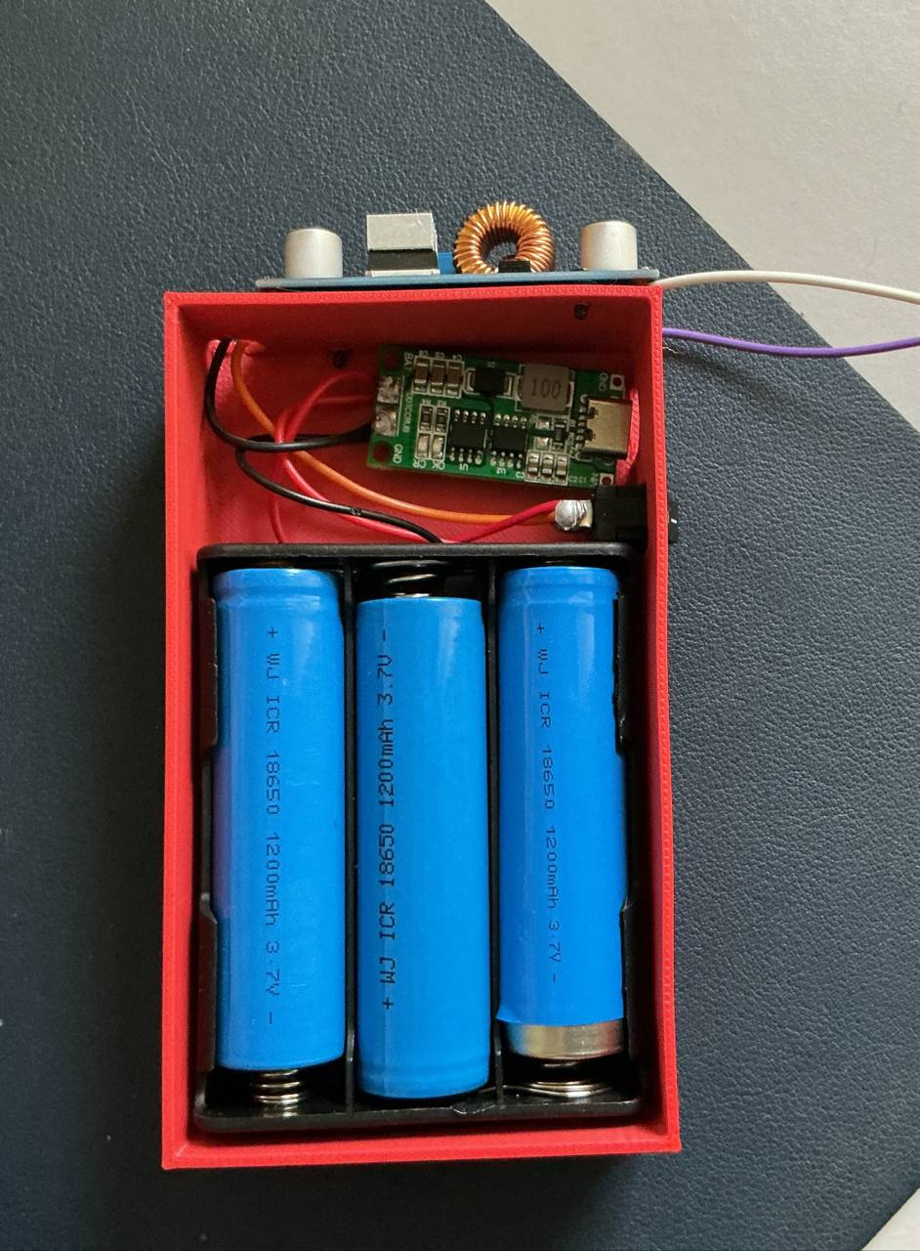
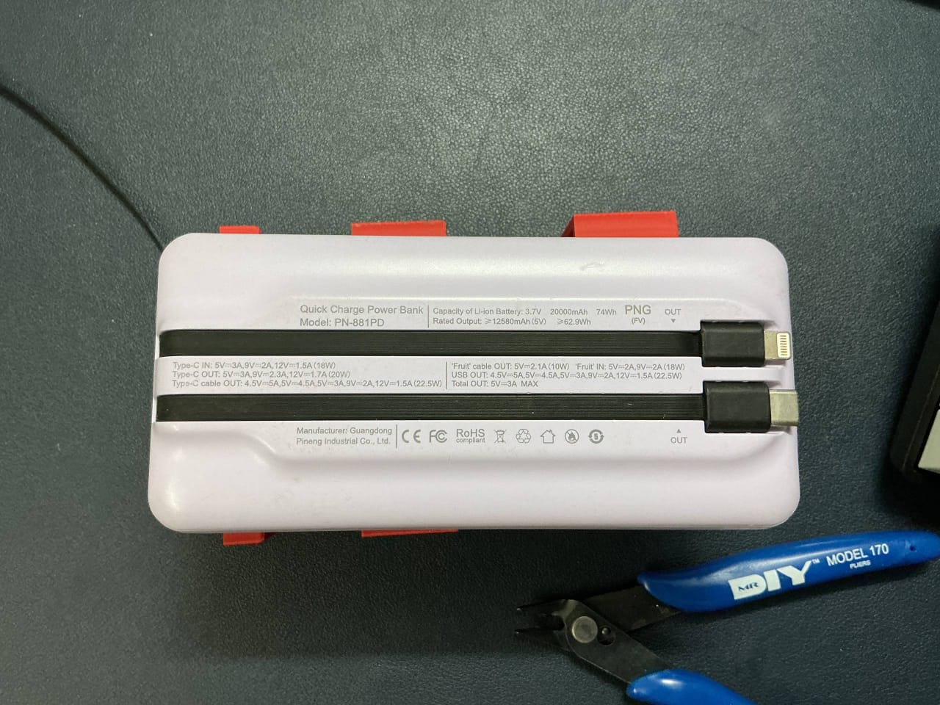

(a) Initial custom-designed battery pack (b) Final commercial power bank
Fig. 10 Evolution of the power supply.
4. RECOMMENDATION
Future development should focus on leveraging the system's readiness for use even under hard environmental circumstances and expanding the system's features. Specifically, the GPS system should be improved for the GPS module, especially for faster and better location fixation performance for indoor or covered locations where the GPS satellite signals are not as strong. To ensure the accuracy of the human detection system when working under complete darkness conditions is not impaired, the incorporation of the use of an infrared light source or low-light camera specialist would be appropriate; currently, the HuskyLens must be under ambient light for senior face recognition. Furthermore, for future system optimization of the mechanical design case to be even lightweight and maximized for ergonomics would be beneficial for senior comfort for future optimization.
5. CONCLUSION
In conclusion, the IntelliCane serves as an exemplary proof of concept for utilizing a dual-processor architecture to provide a fully integrated safety and navigation aid for the elderly and visually impaired. By partitioning tasks between a NodeMCU ESP32 for real-time sensor analysis and a Raspberry Pi 5 for AI-based human recognition, the system effectively secures the user's environment within a 30–80 cm range while managing automated night lighting. Experimental results indicate that the emergency SOS and fall-detection functions operate with high sensitivity, dispatching precise GPS coordinates via Telegram with a latency of under 5 seconds. Furthermore, the integration of a high-capacity 20,000 mAh power bank ensures more than 8 hours of uninterrupted operation, validating the system as a practical and robust mechatronic solution for enhanced mobility.
6. ACKNOWLEDGEMENT
The authors would like to express their heartfelt appreciation to Dr. Zulkifli Bin Zainal Abidin for his continuous guidance, support, and insightful explanations throughout the development of the IntelliCane. His expertise significantly enhanced our understanding of interfacing and digital control, which were vital to the successful mechatronics system integration of this project. We also extend our sincere gratitude to the Mechatronics System Integrations laboratory staff and lab assistants for providing the necessary hardware components and technical support that ensured our experiments progressed smoothly. Finally, we wish to thank our classmates for their cooperation and teamwork during the laboratory sessions, which contributed greatly to the successful completion of this research.

REFERENCES
[1] R. Manduchi and S. Kurniawan, “Mobility-Related Accidents Experienced by People with Visual Impairment.” Available: https://users.soe.ucsc.edu/~manduchi/papers/MobilityAccidents.pdf
[2] S. A. Jayaraman et al., “Falls and mobility challenges among the elderly,” Gerontology, vol. 65, no. 3, pp. 281–290, 2019.
[3] A. Aladrén et al., “Obstacle detection for visually impaired people using assistive technologies,” Sensors, vol. 16, no. 10, 2016.
[4] J. M. La Grow and K. Daye, “Barriers to independent travel for people who are blind,” Disability and Rehabilitation, vol. 27, no. 5, 2005.
[5] M. Hersh and M. Johnson, Assistive Technology for Visually Impaired and Blind People. Springer, 2008.
[6] P. Kumar et al., “Emergency response systems for elderly healthcare,” IEEE Access, vol. 8, 2020.
[7] WHO, “WHO Global Report on Falls Prevention in Older Age,” www.who.int, Mar. 17, 2008. https://www.who.int/publications/i/item/9789241563536‌
[8] World Health Organization, “World report on vision,” www.who.int, Oct. 08, 2019. https://www.who.int/publications/i/item/9789241516570
[9] S. Dey et al., “Ultrasonic sensor-based smart walking stick,” International Journal of Engineering Research & Technology, vol. 4, no. 3, 2015.
[10] [10] D. E. Gbenga, A. I. Shani, and A. L. Adekunle, "Smart walking stick for visually impaired people using ultrasonic sensors and Arduino," International Journal of Engineering and Technology, vol. 9, no. 5, pp. 3435-3447, 2017.
[11] M. Islam et al., “Power-efficient wearable assistive devices,” IEEE Sensors Journal, vol. 18, no. 5, 2018.
[12] A. M. José et al., “Cyber-physical systems in assistive technology,” IEEE Systems Journal, vol. 13, no. 3, 2019.
[13] [13] S. A. A. Moiz, M. S. Khan, and A. Ahmed, "Smart Blind Stick with Health Monitoring System using IoT," International Conference on Communication and Electronics Systems (ICCES), pp. 1–6, 2024.

